

Exeter: A Low Carbon Vision

A proposal for action

This report is a call for Exeter City Council to instigate an imaginative strategy involving all organisations and individuals throughout the City to address the challenges and opportunities of climate change between now and 2020.
And beyond ... to 2030.

The vision is to collectively reduce the city’s emissions of CO2 and to achieve a change in culture that inspires residents, businesses and other organisations to each take steps to adopt and implement a low carbon economy.

It also anticipates further challenge and change between 2020 and 2030, aiming to secure maximum benefit from the opportunities of becoming a leader in low carbon economy.

In summary this report calls for:
- Setting an ambitious but necessary target. 45% reduction by 2020. 90% reduction by 2030.
- Developing an attractive vision of a low carbon city.
- Creating a community-wide Carbon Descent Action Plan.
- Measuring progress and inspiring individual action by setting up Carbon Rationing Action Groups.
- Creating momentum to ensure that the low carbon ethic becomes an integral part of Exeter life.
- And doing all this under a new democratic process; a “Local Agenda 21” style community led process.

1: An Ambitious Target:
We have established two targets that are more challenging than the ones set by government.

There is a good reason for this; the government’s targets are weak and dangerous.

The reason is that the government’s target of 80% reduction by 2050 is predicated on a 50% probability of keeping global temperatures below 2° C above pre-industrial levels. No one would fly in an aeroplane if there was only a 50% chance it wouldn’t crash, and yet we appear to be quite happy to take that level of risk with our climate.

We have used research by M Meinshausen et al. published in Nature 458 (March 2009) to calculate the emissions permitted under different probabilities of success.. This research correlated the total volume of CO2 emissions over the first half of the 21st century against the probability of keeping global temperatures below 2° C.
It establishes that for a 50% chance then only 1,440 gigatonnes of CO2 can be emitted between 2000 and 2050. This has led to the assumption of 50% global emissions cuts by 2050, and 80% cuts by industrial nations. (See graph below)

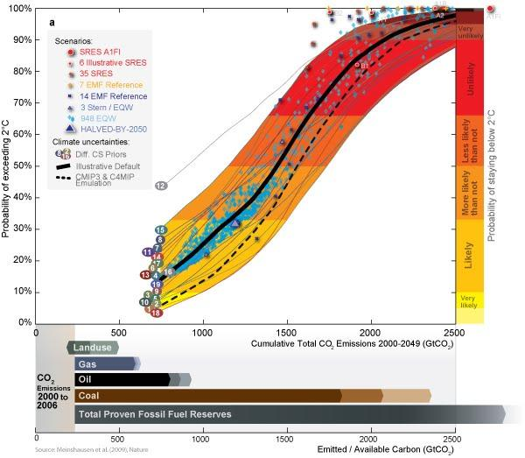

But should we not try for better odds that 50:50?

We used the PRIMAP model (Potsdam Real-time Integrated Model for probabilistic Assessment of emissions Paths) to establish emissions with improved probabilities. See http://www.primap.org/

If we choose a 70% probability of keeping below 2° C, then global emissions should be less; 1100 gigatonnes. On a pro-rata population basis this is equivalent to approximately 10 gigatonnes for the UK.
In the first 10 years of this century emissions from the UK amount to 5.4 gigatonnes, so it if fairly clear that carbon emission cuts from 2010 need to be quick and deep.

The carbon descent graph for Exeter would follow a similar curve to that for the UK as a whole. The percentage reductions relate back to 1990 baseline emissions.

We have developed the following graph that fits reasonably well with a 70% probability of keeping below 2° C.
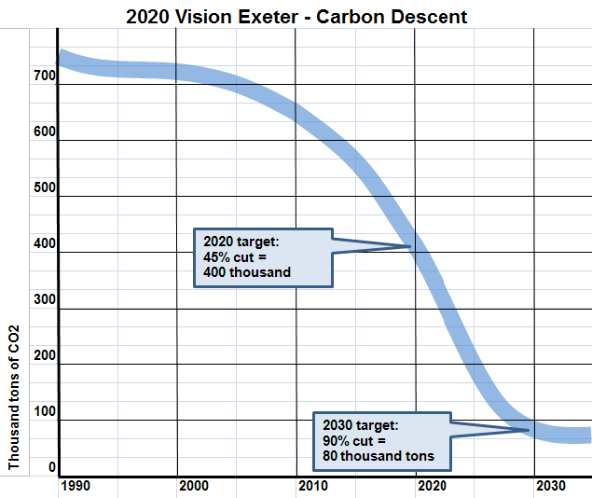

The figures for CO2 emissions are from the government’s published statistics for Local Authorities:
(http://www.decc.gov.uk/en/content/cms/statistics/climate_change/data/data.aspx)

In 2007 (the last figure released) CO2 emissions from Exeter were 673,000 tonnes.
This is less than the national average for 3 reasons, Exeter has warmer weather therefore heating bills are less, it is a city which has more efficient travel patterns, and also Exeter has very little industry.

There are no published figures for Exeter’s CO2 emissions in 1990 (the baseline figure for reductions calculations). But Exeter University Centre for Energy and the Environment has estimated what they would be in their report: “Exeter Climate Change Strategy Analysis” (Jan 2008). They calculated 736,000 tonnes.

Thus CO2 emissions figures available for Exeter are as follows:

Year | CO2 emissions  (tonnes) | Source | N186 Indicator  (tonnes)
1990 | 736,000 | Estimated - Exeter University CEE
2004 | 705,000 | From DECC LA dataset
2005 | 667,000 | From DECC | 622,000
2006 | 694,000 | From DECC | 635,000
2007 | 673,000 | From DECC | 614,000

The government also produces a series of indicators (referred to as N186) to identify how the Local Authority is performing against its indicator target. These figures are also shown above.

However there is one important aspect missing from the above figures; air travel.

The following table includes the impact of air travel emissions on Exeter’s total CO2 emissions:

Year | CO2 emissions  (tonnes) | Add in estimated air travel emissions (*) | Total CO2 emissions | % due to air travel
1990 | 736,000 | 83,000 | 819,000 | 10.1
2004 | 705,000 | 178,000 | 883,000 | 20.2
2005 | 667,000 | 197,000 | 864,000 | 22.8
2006 | 694,000 | 203,000 | 897,000 | 22.6
2007 | 673,000 | 204,000 | 877,000 | 23.3

(*) Based on a pro rata population figures for Exeter and the UK. Uses UK Domestic and International air travel CO2 emissions and assumes a 2.7 Radiative Forcing Index multiplier.

Since air travel emissions in Exeter are calculated to be over 23% of total emissions they should not be ignored, and must be taken into consideration when developing a low carbon vision.

2: An Attractive Vision:
A Low Carbon Exeter will be recognised as a wonderful and exemplary place to live and work:

- A cohesive community with the majority of its needs met locally, involving local people.
- Improved health and well-being created by increased walking and cycling.
- Less cars and lorries on our roads, a quieter streets, and safer areas for children's play.
- A vibrant and dynamic local economy, resilient against the shocks that can be created by a global economy.
- More trees and green spaces.
- An economy that is prepared for the eventual economic crash caused when peak oil occurs, and ready to lead the way in zero economic growth.
- Forward thinking zero carbon developments and retrofitting of existing buildings.
- Increased proportions of renewable energy, food and building materials produced locally.
- Less pollution, better air quality, and enhanced biodiversity.
- Less time spent working, and more time for living.
- Zero waste and full re-use and recycling.
- Reduced consumerism and more focus on the real issues that drive our lives.

We propose that this vision is brought forward in conjunction with the creation of ideas for a Carbon Descent Action Plan developed by the Exeter and District community.

3: Carbon Descent Action Plan:
The concept of Energy Descent Action Plans is well explored as a central component of the Transition Movement. But it appears to us that for the next 10 years, the priority should be focused purely on CO2 emissions, because it reflects the main emergency criterion. This is why we propose a Carbon Descent Action Plan. But in all essence it should be developed in a similar way. It is also essential that we move quickly towards measuring and understanding the currency of carbon.

A crucial aspect of the Carbon Descent Action Plan is that it is developed and maintained by the community as a whole. It must happen as a “bottom up” plan, that is supported by “top down” policy-making from Local Authorities (and Government itself). The reason for this “bottom up” approach is two-fold: (a) it harnesses the expertise and creativity of Exeter’s citizens as a whole, and (b) it is easier to implement a plan that has widespread acceptance and understanding.

For an example of a Carbon Descent Action Plan in progress, please refer to Transition Town Totnes’s EDAP which is on the following weblink:
http://totnes.transitionnetwork.org/EDAPwebversion
Useful reading with over 350 pages of inspirational writing.

The detailed components of a Carbon Descent Action Plan might be as follows:
- Local Food
- Local Energy
- Transport
- Waste and Consumerism
- Water
- Biodiversity and Green Spaces
- Health
- Education
- Buildings and Development
- Economics
- Community and Local Governance
- Inspirational Communication

4: Measuring Descent - Carbon Rationing Action Groups:
There are two ways in which Exeter’s Carbon Descent can be measured:

A: The Government produces annual CO2 emissions for Local Authorities together with estimated indicator targets (N186). See website http://www.decc.gov.uk/en/content/cms/statistics/climate_change/data/data.aspx
This aspect of measurement is discussed in more detail in section 1.

B: Individuals can measure their own carbon emissions by joining Carbon Rationing Action Groups (CRAGs) (see http://www.carbonrationing.org.uk).

CRAGs carry out measurement of CO2 emissions from Gas and Electricity consumption together with Car, Public Transport and Air Travel emissions.

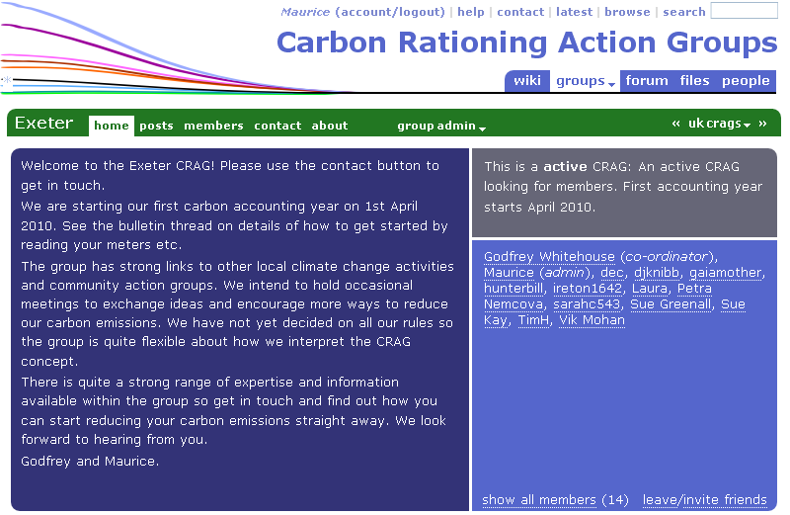

At the moment there is one CRAG in Exeter (see above).
See http://www.carbonrationing.org.uk/exeter

We believe that a large number of pilot CRAGs should be set up throughout Exeter as a network supported by a community website, with the support from Exeter City Council and from existing CRAGs themselves. The annual CO2 emissions from these CRAGs could be collated and used as an index of how Exeter is progressing towards its target.


5: The Low Carbon Ethic:
The success of such an ambitious project as this depends on the majority of the population taking on board the idea of a Low Carbon City. This will not be easy to achieve as it has to be recognised that there is a sense of climate apathy (indeed scepticism). But we believe that if a sizeable chunk of the community can create a buzz about how reducing carbon can create a better city, then this creates its own momentum.

We propose that every opportunity be taken to communicate the seriousness of climate change, and to promulgate the idea of 2020 Vision (or whatever new title is developed for this project).

In particular we need a prominent central location for a huge “thermometer” to identify progress on how Exeter is meeting its Carbon Targets.

6: A New Democratic Process:
Traditionally city-wide plans are developed by the Local Authority and then submitted to a process of consultation, the Local Authority retaining responsibility for its deliver.

We are suggesting that this process be turned on its head. The Carbon Descent Action Plan begins and ends with the community, advised and supported by the Local Authority.

This mirrors a process called “Local Agenda 21” conducted in the 1990s (and beyond) as a response to the Rio Earth Summit in 1992. The thinking was that two thirds of the 2,500 actions identified at the Summit could be delivered locally. As such Local Authorities throughout the world kick-started a series of working groups tasked with developing ideas for action.

The Carbon Descent Action Plan needs to involve the expertise from as many sectors as possible; Architects, Farmers, Business Leaders, Church Leaders, Health Officials, Met Office, Planners, Transportation Specialists, Transport Planners, Environmentalists, Business Forums, Environment Agency, Educationalists, Disability Groups, Newspaper Journalists, our MP and MEPs, Climate Change Officers, Teachers, Lecturers and, indeed, anyone that wants to contribute to a better Exeter.

A similar process is being carried out in Manchester called “A Certain Future”
See http://www.manchesterclimate.com/home for a model of how Manchester is tackling the issue. “It’s Our Plan” they call it.

2020 Vision Exeter:

April 2010


Our webpage:
http://www.2020visionexeter.org.uk

Our facebook group:
http://www.facebook.com/group.php?gid=224685473481

